SIMATS ENGINEERING
ASSESSMENT TOOL 1: Class Test

COURSE NAME: Cloud Computing and
Big Data Analytics

COURSE CODE: CSA15

COURSE OUTCOME COVERED
CO4: Analyze big data characteristics and challenges across domains including security and application aspects.
(BL4)
Assessment Tool Weightage: 40%
Dave&#39;s Taxonomy: Articulation (Level 4)
Question Count: 10

Total Marks: 100

Code of Conduct
I _A.Arthi Reddy(192565054) (Name / Reg No) certify that this submission is my original work and that I have adhered
to the guidelines specified for this assessment.
I understand that any violation of academic integrity rules will result in disciplinary action.
Signature of the student: 
Assessment Tasks
Class Test
1. Define Big Data and explain why traditional data processing approaches are often insufficient for big data
environments.
2. Explain the 5Vs of Big Data with one practical example for any two Vs.
3. Differentiate structured, semi-structured, and unstructured data with examples.
4. Explain the role of distributed file systems in big data processing.
5. List any three major security concerns in big data platforms and briefly explain each.
6. What are data appliances and integration tools? Explain their role in big data workflows.
7. Discuss two major challenges organizations face while implementing big data analytics.
8. Write short notes on any one domain application of big data analytics.
9. How do business drivers influence the adoption of big data solutions?
10. Explain the importance of big data analytics in decision making.
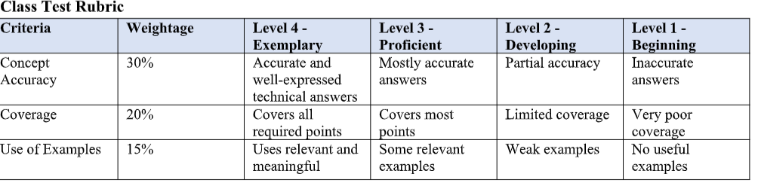
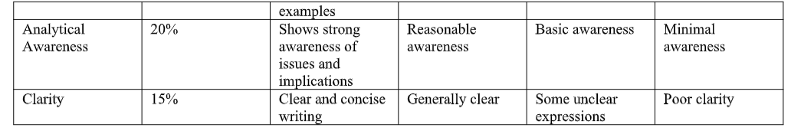
Big Data – Headings with Answers
1. Definition of Big Data
Big Data refers to very large, complex, and rapidly generated data that traditional data-processing systems cannot efficiently handle.
Why Traditional Systems Are Insufficient
- Cannot handle huge volume of data.
- Difficult to process high-speed velocity data.
- Cannot easily handle different varieties of data.
- Scaling traditional systems is expensive.
- Big Data requires distributed storage and parallel processing.

2. 5Vs of Big Data
Volume
Huge amount of data generated.
Velocity
Speed at which data is generated and processed.
Variety
Different types of data such as text, images, videos, and tables.
Veracity
Accuracy and reliability of data.
Value
Useful information obtained from data.
Examples
- Volume: Amazon stores millions of customer transactions.
- Velocity: Stock markets process thousands of transactions per second.

3. Types of Big Data
Structured Data
Data stored in a fixed format such as rows and columns.
Example: SQL database, Employee table.
Semi-Structured Data
Data that has some organization using tags or keys but is not stored in fixed tables.
Example: JSON, XML.
Unstructured Data
Data without a predefined structure.
Example: Images, videos, audio, and social media posts.

4. Role of Distributed File Systems
Meaning
A Distributed File System stores data across multiple computers or nodes.
Functions
- Stores huge amounts of data.
- Divides data into smaller blocks.
- Supports parallel processing.
- Provides fault tolerance.
- Allows easy scalability.
- Improves processing performance.
Example: HDFS.

5. Security Concerns in Big Data
1. Data Privacy
Protecting sensitive information from unauthorized users.
2. Unauthorized Access
Preventing attackers or unauthorized users from accessing data.
3. Data Leakage
Preventing sensitive data from being accidentally or intentionally exposed.

6. Data Appliances and Integration Tools
Data Appliances
Specialized systems used to store, manage, and process large amounts of data.
Integration Tools
Tools used to collect, transform, and transfer data between different systems.
Role
- Collect data from multiple sources.
- Clean and transform data.
- Transfer data to storage systems.
- Connect different applications.
- Support Big Data analytics.

7. Challenges in Big Data Analytics
1. Data Quality
Data may contain missing, incorrect, duplicate, or inconsistent values.
2. Lack of Skilled Professionals
Organizations need experts in Big Data technologies, databases, cloud computing, and analytics.
Other Challenges
- High implementation cost.
- Security problems.
- Data integration.
- Infrastructure management.

8. Big Data Application – Healthcare
Uses
- Predicting diseases.
- Improving medical diagnosis.
- Monitoring patients.
- Developing personalized treatments.
- Managing hospital resources.
- Supporting medical research.
Example
Hospitals can analyze patient records and test results to identify patients at high risk of diseases.

9. Business Drivers of Big Data
Better Decision Making
Provides data-based information for better decisions.
Cost Reduction
Identifies inefficient processes and reduces unnecessary costs.
Customer Understanding
Analyzes customer behavior and preferences.
Competitive Advantage
Helps organizations identify market trends.
Revenue Growth
Helps businesses improve products and target customers effectively.

10. Importance of Big Data Analytics in Decision Making
Data-Driven Decisions
Helps managers make decisions based on actual data.
Trend Identification
Identifies patterns and future trends.
Risk Reduction
Helps predict and reduce business risks.
Customer Insights
Provides information about customer needs and behavior.
Improved Efficiency
Helps organizations optimize their operations.
Business Opportunities
Identifies new markets, products, and revenue opportunities.
Conclusion
Big Data Analytics converts raw data into useful information and helps organizations make faster, smarter, and more accurate decisions.

